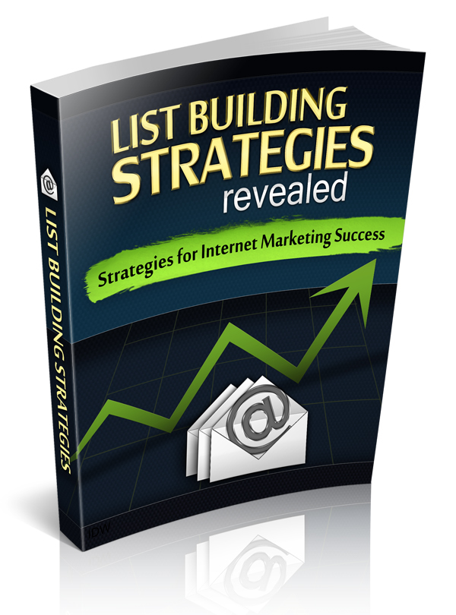

**LEGAL NOTICE**

This book is © All Rights Reserved.

You may not sell this book, give it away, display it publically, nor may you distribute it in any form whatsoever.

While reasonable attempts have been made to ensure the accuracy of the information provided in this publication, the author does not assume any responsibility for errors, omissions or contrary interpretation of this information and any damages or costs incurred by that.

The author does not warrant or represent at any time that the contents within are completely accurate due to the rapidly changing nature of the Internet.

This book is not intended for use as a source of legal, business, accounting or financial advice. All readers are advised to seek services of competent professionals in legal, business, accounting, and finance field.

While examples of past results may be used occasionally in this work, they are intended to be for purposes of example only. No representation is made or implied that the reader will do as well from using the techniques.

The author does not assume any responsibility or liability whatsoever for what you choose to do with this information. Use your own judgment.

Any perceived slight of specific people or organizations, and any resemblance to characters living, dead or otherwise, real or fictitious, is purely unintentional.

In practical advice books, like anything else in life, there are no guarantees of income made. Readers are cautioned to reply on their own judgment about their individual circumstances to act accordingly.

You are encouraged to print this book for easy reading.

Use this information at your own risk..

Contents

**1.Introduction** 4

**2. Do I Really Need a List?** 5

A Quality List Protects Your Business 6

**3. What Kinds of Lists Are There?** 9

**4.How Do I Start Building My Own List?** 11

Get Your Name Out There 11

Work With Complementary Businesses 14

Leverage the Power of Advertising 15

Participate in Joint Ventures 20

**5.Building Your Credibility As You Build Your List** 27

# 1.Introduction

If you have been around Internet marketing for any length of time, you’ll agree that everyone is talking about building a list. And in a real sense, it’s true that you cannot really claim to have an Internet business if you don’t have a group of people who have signed up to receive your emails and are poised to follow your advice and buy the products you recommend. Internet marketing is very personal, not distant or automated. Until you begin to build the relationship with each of your readers, as if you were talking to each person one by one, you may be deceiving yourself about your long-term chances of success online. So how do you get started? Keeping reading to find out!

# 2. Do I Really Need a List?

If you spend any time researching Internet marketing, you'll find out quickly that there are some people who say list building is not as important as it used to be and that you can get along very well in Internet marketing without having a list at all.

Don’t believe a word of this nonsense.

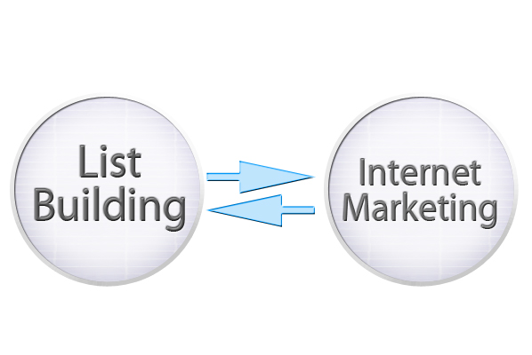List building and Internet marketing are two sides of the same coin. You can’t have one without the other.

**Building a list is simply the most important task that an Internet marketer can do.**

Any so-called guru who advises you that you don't need to build a list is giving some of the worst advice available anywhere on the Internet, and that's saying a lot, because there is a lot of bad information out there. Here is some good information.

## A Quality List Protects Your Business

Neglecting to build a list could endanger your chance of achieving long-term profits online and could even endanger the viability of your business. The CAN SPAM Act of 2003 placed new restrictions on Internet marketers who send bulk e-mails without the consent of the recipient. Everyone hates spam and unwanted e-mails, and this law made it more difficult for unscrupulous Internet marketers to send unsolicited e-mail messages.

The penalties for disobeying this law indicate how serious the law is intended to be.

An Internet marketer can be **fined up to $11,000 per unsolicited marketing   
e-mail**.

You don't have to be a genius to figure out what a few hundred or a few thousand unsolicited e-mails **could do to your lifetime profits.**

Not only do you need your own list, but it must be an opt-in list, which means the recipients have confirmed their willingness to receive your e-mail. This protects you from prosecution under the CAN SPAM Act of 2003, but it also demonstrates your commitment to send only e-mails that the recipients want to receive.

It’s all about treating your clients as you want to be treated.

A Quality List Is Essential to Building Your Business.



When you can identify your **target customers**, you can better sell to them. List building captures your target audience and enables you to communicate effectively with those most likely to purchase your products and services.

People who succeed online spend a significant part of their day focused on building their own list. It's never a secondary activity; *it's the main thing*.

In a real sense, if you don't have a list, you haven’t defined your target audience, and you can’t even get out of the starting gate. A quality list can be a powerful bargaining chip when trying to take your business to the next level. For example, behind every successful joint venture is the power of list synergy. When two or more Internet marketers combine their lists, they can exponentially increase the power of each list alone.

However, if you don’t have a list, you won’t even have a seat at the table.

Therefore, there’s no question that list building and Internet marketing are two sides of the same coin. Ask any well-established and successful Internet marketer what the most important part of the business is. The answer: list building.

# 3. What Kinds of Lists Are There?

Now you know that the first requirement for an Internet marketer is to have a quality opt-in list. There are three kinds of lists, but not all of them are created equal.

1. The first kind of list is the one that you can buy. A cursory search online will reveal all kinds of e-mail lists available at cut-rate prices. However, the quality can also be cut rate.

**You cannot build a solid list by buying thousands of   
e-mail addresses at a time.**

1. The second kind of list consists of potential customers. These lists are valuable because they include people who have visited your website and opted in to your mailing list. Thus, they have expressed interest in you or your product, but they haven't bought anything yet.

**You would be making a serious mistake to underestimate the value of such a list simply because the members haven’t bought anything yet.**

1. The third kind of list is the most powerful and consists of customers who have actually purchased your products or services at least once. These customers form the backbone of your Internet business and provide the greatest recession-proof cash-building strategy on the Internet today.

**The best thing about the third list is that the customers have already demonstrated their willingness to spend money with you at least once.**

For this reason, they are more likely than the other two groups to spend money with you in the future.

# 4.How Do I Start Building My Own List?

So now you may be thinking, "Okay, I'm convinced. Tell me how to build my list."

There's all kind of advice out there about how to build your list, but a few general principles have remained constant for a long period of time. These techniques are effective and practically universal for any kind of online business.

## Get Your Name Out There

The most basic way to build your opt-in list is to write short articles and submit *them* to article banks. This simply means that you write about 300 to 400 words of helpful advice on a particular topic, and you submit the article to a directory that allows other websites to use that content while giving credit to you as the author. But here’s the important point related to list building: The beauty of submitting articles to a directory is that you can include a resource box with your name, your website URL (also referred to as a backlink), and a short description about yourself. When readers click the backlink to your website, you have an opportunity to build your opt-in list.

Submitting articles to directories is not rocket science, but you do have to be careful that your content is always helpful and well written. For this reason, you must ensure that your articles have eye-catching titles and solid content. You want webmasters to search the article directories for material that you have published.

The process of posting on blogs and forums takes time and a considerable amount of perseverance. You'll probably need to dedicate at least an hour a day, every day, if you choose to employ this strategy. However, as your name begins to show up in various contexts, you'll notice three main advantages:

1. blog comments and forum postings act as free advertising,
2. good quality content will enhance your credibility, and
3. backlinks from popular websites can increase your own ranking in the search engines.

You'll want to make sure that the time you spend online is strategic. This means that you want to post on blogs and forums that have a high page ranking, which will in turn enhance the value of the back link to your own site.

Perhaps you are not blessed with writing ability, or maybe you are very tight on time and can't devote the effort necessary to write articles that other webmasters would want to publish. That's perfectly understandable. A great solution is to recruit ghost writers to develop your articles for you. You can also join a site that allows you to repurpose content and claim authorship. This term is called private label rights, or PLR. This type of content allows you to change the wording in any way you like and claim to be the author. As you can imagine, this type of content is extremely popular online.

If you're buying PLR from a website, remember to change the content and make it personal to you.

Rewriting content will prevent search engine spiders from flagging your article as a duplicate of content posted to other sites. As you’re rewriting the articles, remember that they don't need to be much longer than 300 to 400 words, and they should contain the keywords that you are targeting. And be careful not to post anything that looks like an outright advertisement for your website when submitting your article to directories. This practice is frowned upon in the industry.

You will also have to be persistent. You'll need to post three to five times each and every week so that your signature file in the resource box is providing lots of quality backlinks to your website as webmasters publish your content.

## Work With Complementary Businesses

**Exchanging links** with other websites that sell complementary but not competitive products and services is another great way to build your list. Exchanging links simply means that you post someone else's link on your site in exchange for their posting your link on their site. Be sure to choose websites that could never steal your customers.

As you can imagine, it's very important that you don't send your readers to your own competition. Some Internet marketers do not believe in link exchanges for this reason. It's hard to predict what readers will do. Some marketers don't like two-way traffic in any form, and they don't believe that webmasters should ever post a link that directs traffic away from their own website.

However, a link exchange, if done correctly, will bring traffic to your website that you might not have had otherwise.

Potential link exchange partners should have a page ranking at least as high as yours and preferably higher. Every new person who visits your website is a potential customer, or at the very least, an addition to your opt-in list. While you do have to be careful not to participate in link exchanges with competing websites, choosing your link exchange partners carefully will generate reader loyalty for yourself if your readers value the complementary products or services you’re promoting.

## Leverage the Power of Advertising

Every successful business anywhere in the world has learned the value of consistent and clever advertising. Marketing your business, if done correctly, will always pay greater dividends than the expense you incur. Advertising on the Internet is a little different than print advertising. There are principles in common between the two, but the Internet has changed a lot of things about business, including marketing.

There are millions of websites on the Internet, with more being added every day. You're going to have to find a way to tell people who you are and what you can offer them, or they'll never even find you.

There is no way to get around the principle that   
**advertising** **is crucial to list building.**

First, let's discuss **advertising that you pay for**. When most people search online for help in a particular area, they begin their search by using keywords. That means that the major search engines are the keys that open the door to information about helping people solve their problems.

Your job as an Internet marketer is to make sure that it's your door they open, not your competitor’s.

Your advertising budget will almost always need to include a significant amount **for pay-per-click (PPC) advertising.** You'll want to set a budget before you get started, because the expenses can ratchet up faster than you think. Set the limit as high as you can and begin to increase it as sales come in.

Although PPC advertising is not free, it can be very effective for beginning Internet marketers. Submitting articles to directories and participating in link exchanges will build your traffic at practically no cost, but both of these strategies take a lot of time. It could be weeks or months before you see significant increases in traffic as a result of article submissions and link exchanges.

PPC campaigns can bring results almost immediately. While you'll have to budget carefully, you could see more traffic coming to your website almost immediately if you have created the right kind of PPC campaign. You can achieve even better results if you give away something valuable for free. People love free things, whether reports, software, e-books, services, and so forth. And the item being given away is free and of value, people will be drawn by nothing more than curiosity or the desire to get something for nothing. However, from your perspective, the price that readers are paying for your report is their e-mail address. *This is how you build your list*.

**There is no substitute or shortcut** for   
building a list and credibility.

Another very effective way to use paid advertising to your benefit is to advertise in e-zines that are related to the topic of your website. **Targeted e-zine advertising** could provide you a higher return on your advertising dollar because it is more likely that those in the reader audience are interested in what you have to offer. Not only do e-zines allow you to target a very specific group, they also allow you to get more bang for your buck. You can usually get an advertisement in an e-zine for $30 or less.

Whatever method you choose to build your list, remember that nothing can substitute for an established customer list (a list of customers who have paid for your products or services at least once) and your solid online credibility.

Another very effective way to use paid advertising is **traditional print media**. It’s good to be humble and remember that Internet marketers did not invent advertising! Print media have dominated the marketing world for centuries, and today’s Internet entrepreneur would be foolish to ignore the accumulated wisdom of countless experts in traditional media, such as newspapers, magazines, billboards, even the humble business card.

Have you ever thought of using a **business card** to build your list? You should. It’s very cheap and can be quite effective when offered one-on-one to a potential client.

Many traditional marketers have noticed a new appeal for traditional media marketing because consumers are inundated with online offers and might actually read your sales material if they could hold it in their hand. Even a simple postcard with some teaser copy and a website address can do wonders for building your list.

Of course everyone's favorite topic is **free advertising.** There are some methods that you can use that won't cost you any money at all. However, it's important to remember this principle: money buys time. If you don't want to spend any money for marketing your website, you're going to need to invest some time. It is crucial to note that you will always have to pay something for advertising: either your money or your time. So in that sense, nothing is really free.

You will always have to pay something for advertising: **either your money or your time.**

One unique advantage of free advertising could be more valuable than the money you save.

The methods that are most effective in free Internet marketing can build your credibility in your niche market at the same time.

As your name begins to surface in online venues visited by your target audience, your reputation will become more established, as long as the content you are producing is of the highest quality.

The first and most accessible method of free advertising is to **write articles** and submit them to directories. As discussed before, the key value of this kind of advertising is the inclusion of back links to your website in the content. If the content in your article is good, webmasters who publish your article on their websites will include your resource box, linking back to your site.

The second method of free advertising is to join **blogs and forums** dedicated to your niche. As you visit the forms and interact with the people there, you will understand the particular rules that you need to follow. It's very important to stick within these guidelines as you interact with people on the blog or forum. As you become more comfortable with your audience, and as you build your reputation, you could begin to include links to your website.

## Participate in Joint Ventures

When you are ready to take your established customer list to the next level, it might be time to seek a **joint venture**. It's ironic, but up to this point, you may have considered joint venture partners as your competitors. These potential partners manage websites that may draw your target audience away from your website. The names on their list are closely associated with your own customer base. You want their customers to be on your list, and they would say the same thing about you. Joint venture partners may not automatically want to do a deal with you. One of your most important assets will be your list of established customers.

The quantity and quality of members in this list will greatly determine your influence in securing any **joint venture opportunity.**

First , you must convince potential joint venture partners that your product or service will help their customers and their business. Let's say that you make widgets. You and several other companies are in the widget business. If you as a widget manufacturer have developed a solution that makes widgets work better, sell easier, or be more valuable, then you can take your widget business to the next level. You simply approach your competitors and explain the product you've created.

While this process may seem counterintuitive, you actually can turn your competitors into joint venture partners. You have to manage this deal carefully, but if you do, you may find that your former competitors assist in promoting your new product – for a healthy commission of course.

One proven method for building your established customer list is to **offer membership sites** (one that is free and one that is paid) and low-priced products or services. For example, after a person is on your potential customer list, the quickest way to move them to your established customer list is to offer a product or service that is relatively inexpensive. In fact, you could promote such low-priced products with a joint venture partner and even allow your partner to keep 100% of the profit.

That's right. 100% of the profits.

That might be hard to swallow, but you need to keep the big picture in mind. You may have lost a sale, but you've gained a customer. If you manage your list correctly, that customer will be yours for life. Your established customer list is your own private gold mine. As your established customer list grows, you will become more and more attractive to potential joint venture partners, thus adding exponentially to your bottom-line profits.

There is also the power of the **joint venture giveaway.**

Retail stores have always offered a free sample to entice potential clients to buy a product. But the online giveaway event takes this method to a new level. Can you imagine a bunch of retail stores getting together and deciding that their business model was to give away their products? In fact, retail stores wouldn't even consider giving away something to enhance the business of a competitor. In a traditional brick-and-mortar environment, this makes no sense. But it is being done today on the Internet.

The main idea behind the concept of joint venture giveaway events is that people are more than just clients.

People who shop online have parents, spouses, pets, hobbies, dreams, concerns, and so forth. People who have one hobby may also share characteristics with a completely different group. For example, people who love bass fishing may also be concerned about their retirement account.

Successful Internet marketers noted the complexity of their clients and devised a new way to take advantage of the wide variety of interests of the people on their lists. Thus was born the joint venture giveaway.

This special kind of joint venture is limited to a specific number of partners, each of whom offers a free gift to entice people to join their list. The item giveaway is almost always digital and downloaded from a website. A common example is a specific report explaining how readers can solve a particular problem.

After the partners of the joint venture giveaway have agreed on the process, each sends the entire list of free gifts to the members of their own list. This means that people who sell Internet marketing e-books on their own website will also offer free reports about other topics of interest as well.

You can network with people that you've met online, or you can look for **joint venture giveaway** partners using your favorite search.

When the idea of the joint venture giveaway first became popular, it was limited to the months just prior to the busy holiday shopping season. Now Internet marketers conduct joint venture giveaways all throughout the year. It has proven itself to be one of the most effective ways of list building.

Setting up your own joint venture giveaway is not that complicated. You can network with people that you've met online, or you can look for joint venture giveaway partners using your favorite search.

But you should be aware of one thing: joining partners with other online marketers for a joint venture giveaway means that you will be obligated to give every gift being promoted by the partners in the group.

In any joint venture, you want to choose those gifts and the partners behind them very carefully.

You can always create your own joint venture giveaway, although this does take a bit more work. Instead of advertising for joint venture partners to participate with you, you can simply seek out partners one by one and limit the number of people involved in your giveaway campaign.

For example, if you sell Internet marketing informational products, you might look for other marketers who have products totally unrelated to your niche. The key is to be as versatile as possible and always offer value to the people who signed up for your list.

People who shop online and join lists are just like everybody else: They're multidimensional and complex. They are interested in many different things and are not one-dimensional in any way.

You may be surprised to learn that joint venture giveaways can build your list faster than just about any other strategy.

# 5.Building Your Credibility As You Build Your List

The advantages of using the above methods are not just short-term profits. Internet marketers who develop an established customer list and a measure of credibility online are in a most enviable position: They can negotiate the most lucrative joint venture deals with top players in the industry. Your name, and the credibility that goes with it, is your most valuable asset for continuing online success. Here’s the formula:

**Internet Marketing Success**

**Authority Status in the Industry**

**Customer List**

Why is credibility equally important to list building? It's the difference between being an unknown and an authority figure within your niche.

The established customer list will add to your online credibility, but you must also elevate your status by writing and submitting articles to directories, posting to blogs, commenting on forms, and so forth. After you've made a name for yourself in your niche and are on your way to developing widely recognized credibility, then the only other piece of the puzzle is a valuable product or service that will make your joint venture partners look good to their own list members.

**That's how online fortunes are made.**